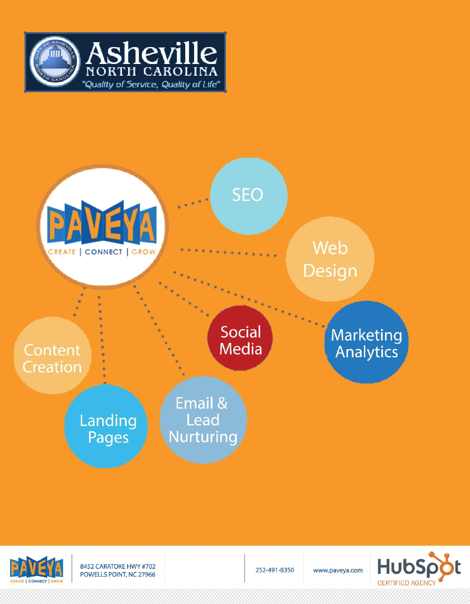


AIRWEB

Page 1 of 18

TO:

FOR:

Christy Edwards

City of Asheville

cedwards@ashevillenc.gov

www.Ashevillenc.gov

PROPOSAL FOR WEBSITE REDESIGN SERVICES – City of Asheville RFP #: 298-WebsiteRFP 11141400.pdf

TABLE of CONTENTS

- PROJECT BACKGROUND

- PROJECT OBJECTIVES

- PROJECT PROCEDURE

- SCHEDULE

- PROJECT TIMELINE SCHEDULE

- DEVELOPMENT PROCESS

- DETAIL COST BREAKDOWN

- ABOUT AIRWEB

- WHY CHOOSE AIRWEB

- OUR KEY PERSONNEL

- AIRWEB CASE STUDIES

- AIRWEB TESTIMONIALS

- AIRWEB PARTIAL PORTFOLIO

- AIRWEB REFERENCES

Page 2 of 18

1.0 PROJECT BACKGROUND
Oando PLC is one of Africa’s largest integrated energy solutions provider with a proud heritage having a primary listing
on the Nigeria Stock Exchange and a secondary listing on the Johannesburg Stock Exchange with shared values of
Teamwork, Respect, Integrity, Passion and Professionalism (TRIPP) seeks redesign, remodelling, and addition of
New Features on the Website https://www.oandoplc.com. Its existing website was built in 2006 ; having served the oando
well,technology expectation has to be met using new innovations in relations to new technological advancements in a ever
developing present day fast developing Technology World. Oando is looking for distinctive modern site to reflect
diversity, character and uniqueness of oando. It needs to be responsive to Mobile Devices, intuitive to
easily find information and accessible (handicapped access) Globally.
1.1 PROJECT OBJECTIVES
Oando plc seeks a responsive, browser independent website to function as a key information resource for the
community. The proposed website will use CMS platform with a clear, intuitive and easily searchable design so that
customers around the globe, businesses and visitors are able to maximize their knowledge of product information, Buy products online with an online payment gateway, Chat with Online Customer Care Representative, Nearest Office/Filling Station/Seller Locations Finder, Network Based Investment opportunity where investors can earn by investment and referals, Chat Room where customers can communicate and give feed backs on purchase products, Digital coin for Oando (OANDOCOIN) and Oando Mobile Software Application.
Oando provides a diverse list of services to the World. While many of the services are administered through centres, the company’s website will function as a gateway and “one stop shop” to provide access to all that Oando has to offer. Therefore, the site will provide links to external databases, GIS mapping information, online utility payments, and reporting tools, activity registrations, engagement tools and social networking.
While there is a lot of important content on the existing site, we feel that the design and navigation of the site should
also be fun. There is so much the Oando has to offer and I feel, through superior design, that we can convey the dynamic
energy and diversity to all who visit the site.
To accomplish the above, the site must be easy to maintain and easy to update with new content. Blogs and social
media should engage the public to return and seek out what is happening. Administrators in the Information
Technology Department and Communication and Public Engagement Division and content editors in each of the Oando’s
departments will all be able to add new information to the site, as needed. Since the site will require timely updates,
the process to update must be simple and efficient using several sections or template types and corresponding
cascading style sheets so the current and future staff will be able to easily update the content, news, calendar, building
data and generally maintain the site.
The website must use the Oando’s active directory to authenticate users based on roles to manage permission to update
the site and provide an audit trail and roll-back utility for prior changes.
Our design will allow the City to host the final design on premises-based city maintained servers or the cloud as
resources or preferences dictate.
The site will be search engine optimized and designed with page load speeds to provide an enjoyable user experience.
We believe the site should be simple yet visually appealing with type that is easy to read, uncluttered pages and dynamic
use of imagery, video and other devices. The home page will highlight blogs and social media posts to engage the public.

Page 3 of 18
1.2 PROJECT PROCEDURE

Requirements Gathering and Documentation

In this phase of the web design project we gather the project requirements and details needed to develop
formal solutions and document all of the Oando Plc's goals. It’s this research and discussion that help the project
process go smoothly and insure that we have all the requirements, needs and “wish list” items identified. Light Technologies Inc believes the design process is a collaboration that fuses our creative strengths with your in-depth understanding to produce a website that will exceed expectations.

Project Planning
During this phase, we will have project meetings with the Information Technology Department, Communication and
Public Engagement Division staff, as well as, any other staff needed to review design ideas, gather content, review
layouts, and set requirements for subordinate sites etc. It is not within the scope of this project to correct any
accessibility issues (ADA / handicapped access) regarding sub-domains. Light Technologies inc. can also provide the client with a designated log-in and password to access our project management software, where all project communication can filter. This can also serve as a central repository for existing content from stakeholders while the site is under development.

Integral to the success of https://www.oandoplc.com will be the design process and creating a professional face for the new
website. The site must be clean and sophisticated, present information in a way that is useful to the user and allows the
user to quickly locate what is needed. To that end, Light Technologies inc will work closely with the client to create a design that meets
with their approval while drawing on their own experience in city management. Paveya will utilize InDesign/Photoshop
software to model 3 to 4 design concepts, as needed, to provide the client with the best overall design possible. All designs
will be responsive to maximize the users experience on mobile devices.
Proposed Site Map

Once the planning stage is complete, a site map will be developed and agreed upon.

Website Development

Light Technologies inc. will utilize WordPress CMS to develop the website and provide maximum flexibility to maintain and update the site for the City of Oando plc.

There are certain key design features that will be built into the overall design and each will need to be approved by the client before the final design is accepted. Those features are:

- Navigation: It is particularly important to create a navigational system that is available on every page, maintains the overall feel of the site while making the site intuitive and easy to locate data and information.

- Colors: The design will be built around a coordinated color palette that will provide the professional yet simple look as determined by the Oando plc while maintaining the cohesiveness of the website.

- Fonts: The fonts’ family, size and color combine to maintain a professional and cohesive feel.

- Images: Photos, graphics and individual images will be submitted by the client and may be modified in the appropriate software to meet the overall design requirements of the site. All photos/graphics must be supplied by Oando plc or stock photos without copyright protection can be used.

Page 4 of 18
- Layout: The design must take into account the content that will appear in the site to ensure its usefulness and readability. Certain elements will need to be highlighted more so than others, so Oando plc will work with the client to determine what the best layout should be.

- Overall: Once all the elements are pulled together, the client will determine if the design meets their needs and the needs of the community.

Website Content Migration

The client will provide Oando plc with the content for the following page examples (and additional pages agreed upon during planning):

- Home: This page will be the starting point for most, if not all, users, and so will need to provide the broadest amount of information while maintaining a clean and professional appearance. Oando plc Source will have a source blog which will also have a window on this page.

- Calendar: This page will feature the events and notifications for the Oando plc.

- Resources (to be further categorized): These pages and subpages seem to be full of content and care will be taken to design it so users will be able to easily navigate, search and cross reference items.

- Contact
- Blog

Note: All content is provided by the Oando plc and quote does not include new content creation by Light technologies inc.

On-Page Optimization (One time Initial Optimization only):

Light Technologies inc. shall work with the Oando plc to create comprehensive and targeted Meta Tags and page titles for indexing the site with search engines. After completion, Light Technologies inc. will submit site to all major search engines for indexing. Note: search engines may require a 4-6 weeks to authorize site submission.

- Keyword and key topic research and selection

- Website structure optimization

- Content optimization

- Image optimization

- XML sitemap optimization

- Title tag and meta description optimization

- Google and Bing Webmaster Tools

- URL structure optimization

- Optimize Title Tags

- Meta Tags Creation & Optimization

- Alt-image tags

- Robots.txt Installation.

- Google Analytics Installation.

- Google Sitemaps Installation.

Blogging / Social Media

Oando does not have a blog, so intend creating a blog to feature it prominently on the home page.
Websites that utilize blogs attract 55% more website visitors than ones that don’t. This is because blogging drives traffic
from social media, blog subscribers, and search engines. Blogs also provide SEO enhancement.

Page 5 of 18
A strong social media presence is important for SEO. Oando plc is actively utilizing social media and leveraging
its advantages to reach out its customers. I will continue to integrate the social media links (YouTube, Facebook,
Instagram and Twitter) to the website. We will match the design of the social media pages to the website to provide a
consistent brand for the Oando Plc. Social media is a powerful way to drive website traffic to the Oando Plc's
website.

Site Test, Training and Launch

Light Technologies inc will test each page template type for functionality, accessibility, and browser compatibility for all text and graphics. Administrators in the Information Technology Department and Communication and Public Engagement Division and content editors will be provided with at least 4 hours of hands on WordPress training on the templates and CMS usage to make sure they are able to delete, add and modify content to the site. Oando plc will be provided the final website and all documentation for review, testing and approval.

2.0 SCHEDULE

This schedule defines the major tasks to be completed during the life of the project. Individual tasks may be added,
deleted or moved as required to meet the demands of the design. The times listed below are estimates. A final project
scope and timeline will be communicated following project agreement.
2.1 PROJECT TIMELINE SCHEDULE

Phase I: Strategy & Concept Development

Project launch – 24 Hourss
Begin work on site map/architecture with client - 24 Hours
Content / Images (photos/logos/etc.) delivered to Light Technologies inc 24 Hours
Creative brief to City of Asheville – 3-4 Design themes presented 192 hours
Design concept chosen by City of Asheville (with comments) 72 Hours
Final design submission and City of Asheville approval 288 hours

Phase II: Web Site Design & Development
Site map/architecture

CSS development

WordPress CMS development

Site Development completed

Phase III: Production Management & Implementation

Light Technologies inc begins content migration
Content migration completed to website - 216 Hours
Light Technologies inc delivers files to Oando Plc for production - 125 Hours
Beta testing of website begins on production server 80 hours
Implementation of final design refinements in response to stakeholder feedback - 150 Hours
Final website launches - 240 Hours

Phase IV: Outcome Evaluation (Optional)

Collect user data and survey information (optional) - 15 Hours
Outcome evaluation meeting (optional) - 1 Hour
Page 6 of 18
2.2 DEVELOPMENT PROCESS

Phase I: Strategy & Concept Development

Great design starts by understanding your objectives, we begin by asking questions. We work to understand the goals of
the Oando plc. We will define any design problems and develop strategies for solving those problems effectively
and memorably. The tiered content approval levels will be established by understanding the process and incorporating
it into the website design.
Using the insight gained from the Oando Plc experts and an analysis of the required content for the site, we will
select several design alternatives that will communicate the material, with minimal modification, to visually express your
core message with intuitive navigation. Every choice, from layout and color to type size and style is made in
collaboration with you and your communication goals in mind. We then present the initial concepts to you and work
with you to turn the concept into a comprehensive design. The best idea will be chosen for further development.
Meetings will be scheduled as needed to accomplish a complete understanding and to foster cooperation among the
entire group of stakeholders and the Contractor.
At this stage we will provide:
• A design brief describing our understanding of the project’s goals and parameters
• A detailed schedule to guide the process.
• Three to four strategic design concepts for evaluation
• Final design selected and signed approval from Oando Plc

Phase II: Web Site Design & Development

Once the best design is selected and approved, the heavy lifting development work is done next. At this phase, we
examine the details, ensuring that every element works to aid the communication objectives of the project. The
architecture and site map is completed. The CSS (Cascading Style Sheets) are flushed out and the WordPress CMS
(Content Management System) is developed.
At this stage we will provide:
• Complete website (skeleton) complete

Phase III: Production Management & Implementation
Now that the proper planning and development is in place, we implement the plan. The final website developed is ready for the migration of graphics and text. We proof and refine the design and content, check, doublecheck, proof again, and prepare the design for the final production environment. Then we proof your project again and
provide the preliminary site to you for review.
At this stage we provide:
• Production proofs for proofing and corrections as needed
• Testing of site for selected browsers, devices (iPhone Android, iPad etc.)
• Accessibility tests
• Training and production management for the finished project
• The finished project, style guide and all documentation
• SEO initial set-up

Phase IV: Outcome Evaluation (optional)
Our work isn’t done after the website launches. We want to know how it’s working. We work with you to gather feedback, and help you to evaluate this feedback to improve getting the message to the target audience the best way possible.
Page 7 of 18

3.0 DETAIL COST BREAKDOWN

Consultation on Website Strategy
Including creation of 3 or 4 design themes | $ 2,250
Project Management Services, including
Scheduling, estimating and client contact | $ 2,250

Subtotal for Phase I: Strategy & Research | $4,500
Web Design Services, including development of site map | $ 3,000
Web Development,
Including CSS conversion, responsive WordPress CMS integration | $ 9,000
Subtotal for Phase II: Creative Exploration & Design Development | $12,000
Content Migration,
Up to 500 pages at $20 per page | $ 10,000
SEO (on page optimization) and Social Media Integration | $ 1,000
Production/Implementation, including
Beta testing of website, resolve issues and launch website | $ 1,000
Training & Testing Consultation, including preparation of
training, testing & documentation materials | $ 1,000
Subtotal for Phase III: Production Management & Implementation | $13,000
Total for Services | $29,500

The cost specified above is valid for 45 days.

Page 8 of 18
4.0 ABOUT LIGHT TECHNOLOGIES INC.

Light Technologies Inc, located in Lagos, Nigeria. We are a Technology company specializing in web design, search engine optimization, web development, content creation, social media marketing, other internet marketing services, Capacity building, Software developement, Data analysis, Office Equipments, Laptops, Phones, Chips, Drones and much more.. We pride ourselves in providing the very best personalized solutions for our customers to achieve their goals. Our talented professionalism can assist your organization's vision by applying strategy and planning to website design, search engine optimization, content management, social media marketing, mobile marketing and other online marketing services. Our creativity and technical skills have combined marketing and web development experience. Light Technologies inc has satisfied clients since 2018.

4.1 WHY CHOOSE LIGHT TECHNOLOGIES INC.

Light Technologies inc. has several competitive advantages that make our firm an ideal fit for Oando plc :

- We have creative ideas that will stand out and stick with your audience — Light Technologies inc. has a unique understanding of marketing logic fueled by intuitive creative thinking. Our perspective allows us to create ideas that resonate with your audience to make a lasting impact with your message.

- You want design that communicates, not just pretty pictures — Our mission is to create materials that influence your audience and further your goals, not just decorate a page. We use our understanding of strategic messaging and create a synergy with the content and graphics to communication your message on multiple levels. The result is more than a good-looking website. It’s an effective one.

- You need flawless timely execution that produces results — Our experience in project management ensures that we quickly grasp the issues, sweat the details and produce a website that exceeds your expectations and instills delight in your users.

Page 9 of 18
4.2 OUR KEY PERSONNEL

Our diverse team of experts at LIght Technologies Inc. allow us leverage the skills of each to best suit the project. Additionally, we are also have a team of developers, located in Nigeria, to further our competitive advantage. Below are some of the key members who will be assigned to the Oando plc project. In addition to the team below, we have several dedicated and qualified staff members who design, write content, perform SEO, execute social media and other Inbound Marketing techniques. The flexibility of our staff to assist in special projects is one of our strengths.

Page 11 of 18
5.0 LIGHT TECHNOLOGIES INC. CASE STUDIES

Over the past year, Light Technologies inc. has designed a diverse group of websites across many industries using several platforms. We would like to highlight a few that have been completed recently or that have similar requirements to the Oando plc website.

Buy Local & Currituck County Tourism Bureau:

http://buylocalcurrituck.com/
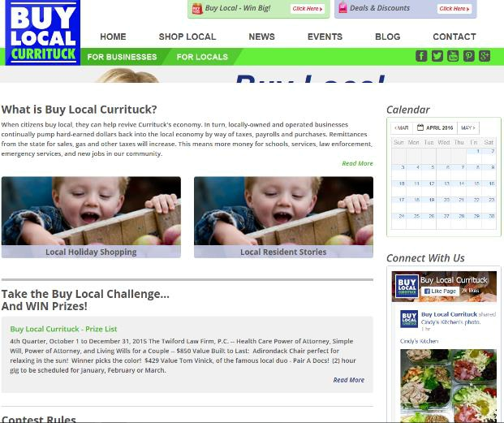

The Currituck County Board of Commissioners contracted with Paveya to spear head the “Buy Local” campaign in 2011. The goal was to encourage citizens to buy local, so they can help revive Currituck's economy.

The County specified a PHP based website. Social media is integrated to the website with sweepstakes and prizes given away to create excitement and increase participation. A custom database was designed and integrated to the platform for local businesses to register. A calendar of events is updated regularly to announce events.

http://www.visitcurrituck.com/

Next, in 2014, the County contracted with Paveya for a WordPress website specifically focused to encourage tourism to the area. Paveya provided all the graphics and design for the site and integrated the database developed under the buy local campaign to leverage and further promote local business. Paveya continues to provide content and SEO support for the site.
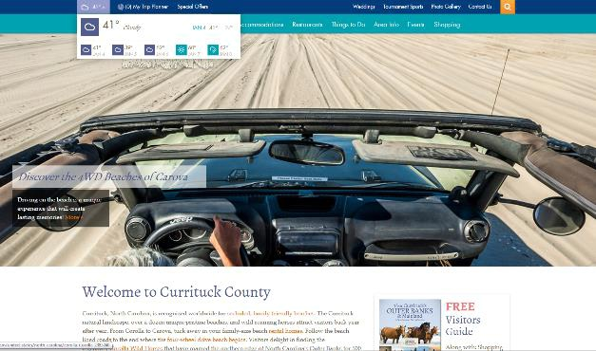

Eillu

http://www.eillu.com/
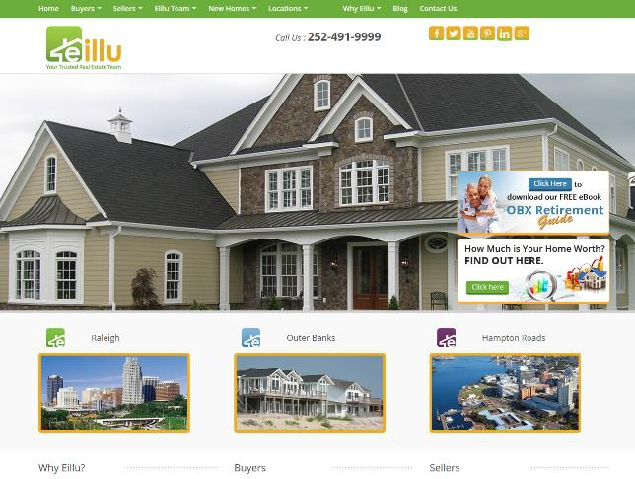
In 2015, Paveya completed several website projects, but we would like to highlight the real estate brokerage website for Eillu. This website is built on WordPress with integration to MLS for up to date real estate listings. Paveya designed the logo, created all the content and graphics; including the content offers, calls to action and landing pages. The site has social media integrations. Paveya continues to create content for the site with blog posts, social media interaction, E-newsletters and SEO.

Page 12 of 18
Roper Mountain Science Center

http://www.ropermountain.org/
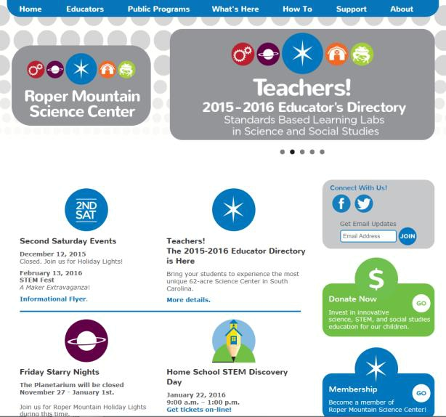
In 1985 Roper Mountain Science Center opened after a joint effort between public education and the private sector. Paveya completed a WordPress website for the educational center in 2014. The client provided the text content and Paveya provided the graphics for a collaborative effort. The site includes a calendar of events, generous use of videos, and integration of membership programs on 3rd party sites, social media integrations, online registrations, interactive maps, and links to public programs. The simple design has served the staff well and they continue to maintain and updated the site.

5.1 PAVEYA TESTIMONIALS

Johnson, Burgess, Mizelle & Straub LLP (Web Design/SEO): “The professionals at Paveya showed us the benefits of having content management and their world class design capabilities. With their On-page Optimization package, Paveya helped Johnson-Burgess rank in the top 10 for keywords pertaining to our business.”

Anita Baughan – Johnson, Burgess, Mizelle & Straub LLP


The Coastal Cottage Company (Web Design): “We would like to thank you and your team of competent professionals at Paveya for creating our company such an incredible website. We have had nothing but positive response since we launched our new site. The website is absolutely gorgeous, functions wonderfully and the amount of edibility built-in is exactly what we needed while we grow.

The website exemplifies the image we want to maintain for our company and we couldn’t be more thrilled to share it with our potential clients.”

We would, without hesitation, recommend you and your company to anyone looking to design and build a new website. You and your team did a great job start to finish and if we need to do it again in the future, Paveya will certainly be the first place we go. Thanks again and look forward working with you in the future.

Michael K. York, The Coastal Cottage Company


Sinbad Sportfishing (Web Design): “We made the best decision when we linked with the team at Paveya for our web redesign. We have spent collectively over 40 years in the tourism industry and when it came time to throw out the old language of our website and embrace

the new, this was the team.”

If your website is a primary part of your communication with your customers, then you want a team that communicates clearly with you to reach that goal. You do not need a background in code. You need only to sit down, give a sense of

Page 13 of 18
who you are and what your business is, and work with Paveya to put those thoughts to the web! PC to Mobile, the uploads were fast, efficient, and gave anyone access to our site!

Our team treated our concerns and thoughts with respect, introspection, and a new polish that integrated whatever capabilities we wanted to embrace for our redesign. Their services could have given us anything from new logo to all the latest social media plugins. The combination possibilities are endless for what you may want to choose. That is not all they offer. After completion we were tutored on use and uploading and if need be, continued to receive complete support no matter how minor the question may have seemed. We never felt abandoned simply because the contract was concluded. Now we are ready. I am already tweaking one or two items on my own and with such a user friendly template to use, it makes it possible to have the content I want to share with our clients exactly where I need it. I want to thank the team at Paveya for the timely redesign, tutor, and open communication that exists still with our new website. We could not be happier with possibilities that exist from the new site!

Cpts. Will & Viv McPherson

Currituck Econ Development (SEO): “Paveya worked closely with us to develop an integrated

solution to SEO: blog postings, press releases, keyword insertions and more. Paveya has helped us reach top-ten Google search status for a number of terms and substantially enhanced page view results for ThinkCurrituck.com.”

Peter Bishop, Director of Economic Development, Currituck County, NC


Buy Local (Web Development/SEO/Database Management): “Paveya plays an integral part in social media marketing for the Buy Local Currituck campaign. By optimizing our website, they have been able to increase our page rank in search engines, resulting in more visitors to our site.”

Diane Nordstrom, Director of Travel and Tourism, Currituck, NC


Dragonfly Inn (Web Design): “When we started the process of opening our own bed and breakfast we didn’t realize we would be paving the way in our area so we had no previous success stories to

review. My husband researched marketing firms in the area of the Outer Banks and Virginia Beach and was impressed with Paveya’s track record. We knew we would need someone nearby and small enough that we could get personal attention but large enough to know the industry. Paveya provided personal attention to our account and website set up. They assisted us with our logo design, which we love! They advised us on marketing and got us pointed in the right direction as we started our bed and breakfast. In today’s world the website is an important tool and Paveya helped us to achieve our goal of an accessible, easy to navigate website that could take online bookings and reach out to the social media world. They even answered our questions and emails on the weekends! I think we are off to a great start with our business—thank you Paveya.”

Lori Evans, Dragonfly Inn

Page 14 of 18
5.2 PAVEYA PARTIAL PORTFOLIO

Below are selected screen shots of Paveya built websites. To see an expanded list, visit our website and our interactive

portfolio: https://www.paveya.com/portfolio/

Real Estate:
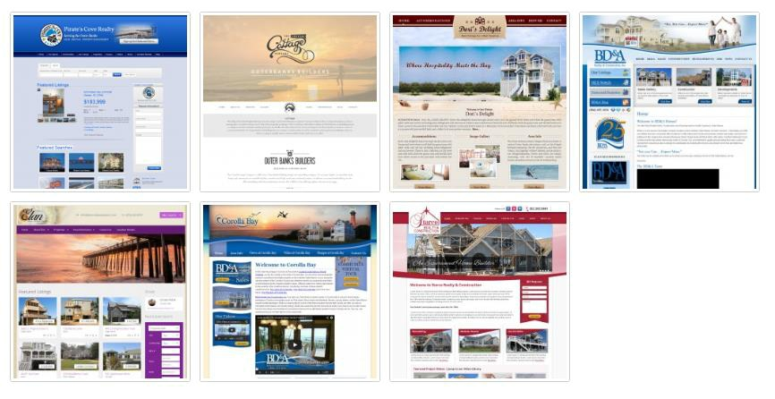

Hotels:
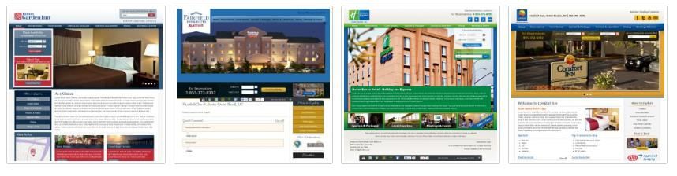

Page 15 of 18
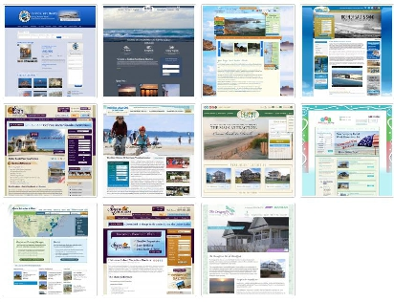
Vacation Rentals:

Professional:
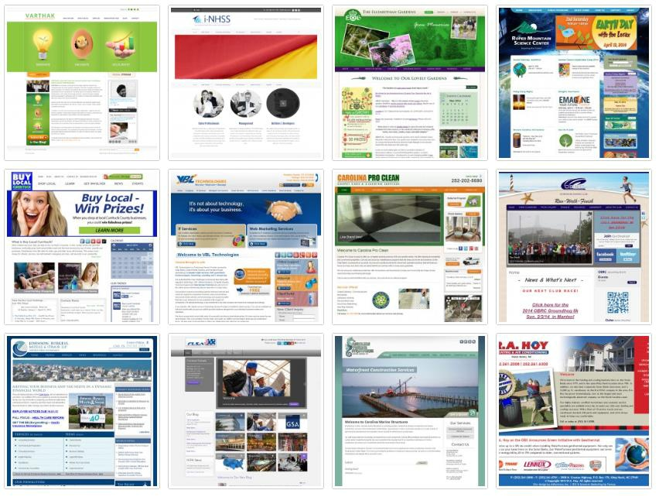

Page 16 of 18
Retail:
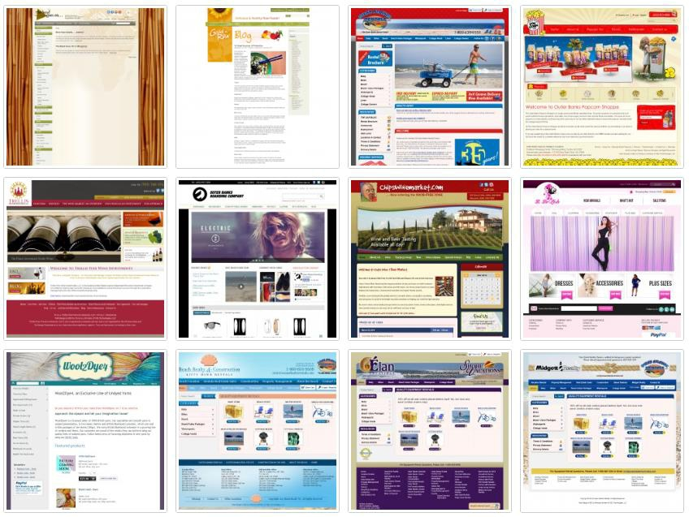

Small Business:
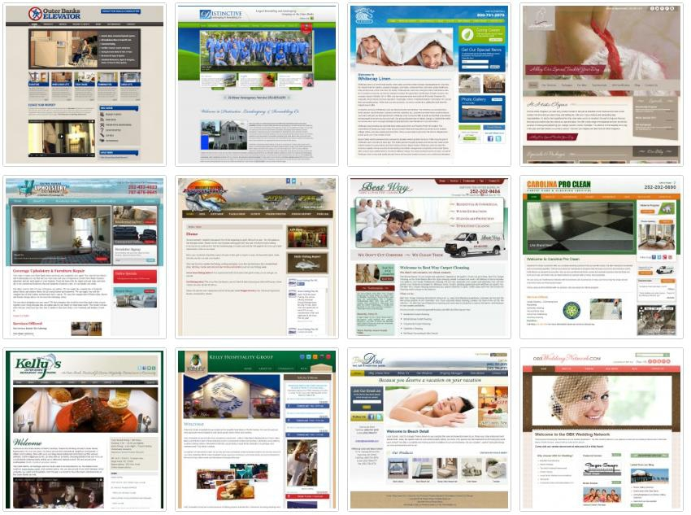

Page 17 of 18
6.0 PAVEYA REFERENCES

Johnson, Burgess, Mizelle & Straub LLC 4016 N. Croatan Hwy,

Kitty Hawk, NC 27949, Debbie Burgess 252.261.2333 dburgess@jbms.net

Currituck County Department of Travel and Tourism 106 Caratoke Highway

Moyock, NC 27958

Stuart Chamberlain 252-435-2947 schamberlain@visitcurrituck.com

Roper Mountain Science Center 402 Roper Mountain Road, Greenville, SC 29615

Michael Weeks 864.355.8900 mweeks@greenville.k12.sc.us

Page 18 of 18

